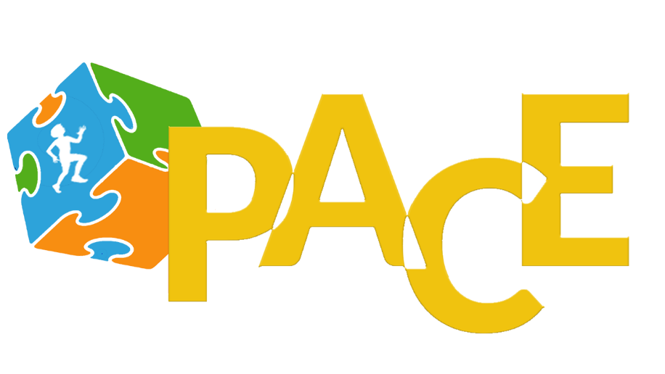 | Vendor Request Form  Saturday, May 9th, 2020  Lake Balboa Park  - Registration @ 6:45 am  - Race Begins @ 8:00 am
PACE RUN for a CAUSE Mother’s Day Autism Awareness
5K /10K WALK/RUN& Kids Fun Run

RACE ATMOSPHERE: The race is family friendly. We welcome vendors who want to enjoy the fun as they engage withthe race patrons.

RULES:
- The vendor must bring everything for the booth (tables, chairs, canopy, etc.)
- Each vendor may have one canopy per booth 10x10 (no tents allowed)
- Each vendor may supply one item for race packets. They must have the
items in no later than April 21st.
- Limited power is available. If vendors require electricity for your booth, pleasebe prepared to provide it for yourself.
- PACE Consulting Co. must approve all food handouts.

SETUP:
- We allot each vendor a 10x10 ft. area to set up
- Boot Set-up: Saturday May 9th from 6:30 am – 7:30 am
- Event wrap-up & Tear-down (volunteers will assist vendors) - 11:30 am
- Event Address: Lake Balboa (Woodley Park), 6350 Woodley Ave, Van Nuys CA 91436

Vendor Request Form

Saturday, May 9th, 2020
Lake Balboa Park

- Registration @ 6:45 am
- Race Begins @ 8:00 am

Date of Contact: ______________________________________________________________________________________

Name of your Company/Organization: ____________________________________________________________

Contact Name & Title: _______________________________________________________________________________

Address: ______________________________________________________________________________________________

City/State/Zip: _______________________________________________________________________________________

Office Phone:___________________________________Direct Phone: ______________________________________

Email: ___________________________________________Website: ___________________________________________

WHAT DOES YOUR ORGANIZATION DO?
Food/Beverage Booth Activity Booth Information Booth
Please give details as to what will be presented at your booth: _________________________________
_________________________________________________________________________________________________________
_________________________________________________________________________________________________________
Payment: Vendor Fee: $100 Non-profit: $50 (only 10 booths available)
Donate online through link
Check (made payable to PACE Consulting Co.)
Credit Card (selection) VISA MC
Card #: _________________________________________________ Exp. Date: _____________ CVV: _____
RETURN COMPLETED FORM TO:
PACE Consulting Co, Nicole Hampton 11304 Chandler Blvd #603 North Hollywood Ca 91603
or email this form to paceconsultingco@gmail.com for consideration
All Forms and payments due by April 21, 2020

